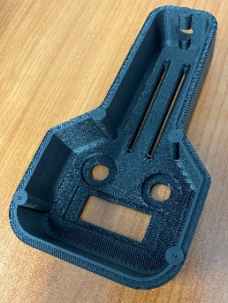
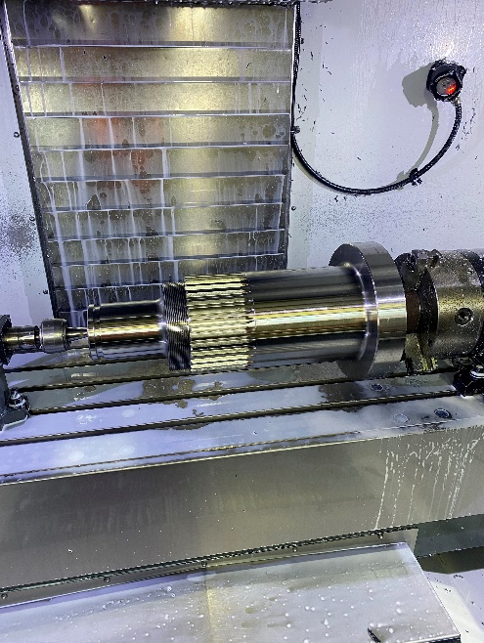


CAPABILITY STATEMENT
INTRODUCTION  Harbro Engineering is pleased to present our exciting new state-of-the-art Additive manufacturing solutions to the needs of the Australian market. We now offer cutting edge Industrial quality 3D printing solutions along with traditional precision CNC and Manual machining and manufacturing services.  Harbro Engineering has 35 years of engineering expertise and our experienced team prides itself in meeting the specific needs of our clients. We now extend our services to rapid prototyping and production of affordable, precision components from small superseded automotive parts to the latest aerospace applications using world leading fibre reinforced plastics and industrial quality metals. Our dedication to providing quality, honest and reliable service, with innovative solutions has enabled us to keep ahead in our industry and we are keen to work alongside any business to help bring their production concepts to reality. |  | KEY INDUSTRIES:  - Mining  - Agriculture  - Transportation  - Defence |  | - Food  - Mechanical  - Marine  - Aerospace
CLIENTS
Harbro Engineering has successfully provided quality components to our local, national, and international clients since 1988, to meet project deadlines with an exemplary compliance record.
 |  | Our clients include:  - Caterpillar Machinery  - Elphinstone  - Jayben |  | - SED Manufacturing Services  - Huon Aquaculture  - Doric Engineering
MACHINING CAPABILITIES:  CNC Machining:  - Haas CNC 4 axis Live tool lathes  - 254mm chuck, 533mm swing, 826mm length.  - VF4 Haas Vertical mills (3+1 Axis):  - X=1270, Y=508mm, Z=635mm.  - 5 axis Omax Maxiem 1530 CNC waterjet cutter.  - X=3000mm, Y=1500mm, Z=200mm  - 60 ° from vertical capability.  - Oxy Acetylene Profile cutter:  - Z=2400mm, Y=1800mm, Z=150mm.  - 9 Axis Durma AD-S 30135 Press brake  - X=3050mm, Y=450mm, 135 Ton press.  - CNC Mandrel bender:  - 80mm Ø tube, 60mm sq tube, 35mm solid bar  Manual Machining:  - 5X lathes Sunmaster up to Colchester Magnum.  - 670mm swing, 3000mm between centres.  - Hafco BM 90HV & Manford 5KV Turret Mills.  - X=1120mm, Y=520mm, Z=440mm  - Butler 8”slotter.  - MIG, TIG, MMA welding and silver soldering.  - Hydraulic pressure testing up to 6000psi  KEY DIFFERENTIATORS  - Rapid prototyping  - 3D scanning and reverse engineering  - One-stop-shop manufacturing  - Post print machining  - Expert technical advice and support | 3D PRINTING CAPABILITIES:  METAL 3D PRINTING.  - 2 x Markforged Metal X printers  - Print volume: W=300mm, D=220mm, H=180mm  3D PRINTING WITH FIBRE REINFORCEMENT:  - Markforged MkII printer  - Print volume: W=320mm, D=132mm, H=154.  - Markforged X7 printer x 2:  - Print volume:W=330mm, D=270mm, H=200mm  - Markforged FX20:  - Print volume W=525, D=400mm, H=400mm.
 | 3D PRINTING MATERIALS
 | Metals  - 17-4 PH Stainless steel  - A2 Tool Steel  - D2 Tool steel  - H13 Tool Steel  - Copper 99.97% pure |  | Thermoplastics  - Nylon (ESD, FR)  - PLA  - TPU 95A  - Ultem 9085
 | Reinforcement:  - Carbon Fibre  - Kevlar |  | - Fibreglass  - High Temp Fibreglass
COMPANY DETAILS
Harbro Engineering Pty Ltd.
ABN 80 009 511 933 | ACN 009511933
26 Ferguson Drive PO Box 687
Spreyton, Quoiba, Tas. 7310
Tasmania, 7310
PH: 0364 249135
E: info@harbroeng.com.au
W: www.harbroeng.com.au

